**J M Baxi**

Standard Operating Policy and Procedures

Project Management

Introduction

Who are the Stakeholders for this SOPP?

This stakeholders for this SOPP shall primarily be activity owners and business units.

1. Activity owners shall use this SOPP as a reference document while performing their activities daily.

Who will use this SOPP?

This SOPP shall be used by only Project team. Most notable shall be the following:

1. Project Director will be primarily using this SOPP for Capex operations.

Rules for this SOP

* This SOPP shall be reviewed on annual basis.
* Any changes in the SOPP will be approved by and then updated by Project Director.

Document review and approval

Revision history

| **Version** | **Created By** | **Document Approved By** | **Date Approved** | **Revision** |
| --- | --- | --- | --- | --- |
|  |  |  |  |  |

| **SOPP Number** | 1 |
| --- | --- |
| **Applicable Entities** | Where Capex Development Project is carried out in Green field, Brown field or any major modification project. |
| **Process Owner** | Project Director and Respective Functional Heads |
| **IT Applications** |  |
| **Guidelines / Policy reference** |  |
| **SOPP Cross References** |  |

**Contents**

Project Management 1

Abbreviations and Definitions 5

Organization Structure 6

PHASE – 1: Planning and Procurement 7

1. Planning and Procurement 7

2. Coordination with Lender 10

PHASE – 2: Construction Phase 11

1. Construction Management 11

2. Budget Escalation 15

3. Project Closure and Handover 17

## Abbreviations and Definitions

|  |  |
| --- | --- |
| **Abbreviations** | **Details** |
| BG | Bank Guarantee |
| BOQ | Bill of Quantities |
| CEO | Chief Executive Officer |
| COO | Chief Operating Officer |
| COP | Certificate Of Payment |
| DLP | Defect Liability Period |
| DLR | Daily Labour Report |
| DOA | Delegation of Authority |
| DPR | Daily Progress Report |
| GFC | Good For Construction |
| HO | Head Office |
| HOD | Head of Department |
| HSE | Health, Safety & Environment |
| IE | Independent Engineer |
| ITR | Inspection Test Report |
| KPI | Key Performance Indicators |
| MIS | Monthly Information System |
| NCR | Non-Conformance Report |
| PD | Project Director |
| PEP | Project Execution Plan |
| PM | Project Manager |
| PO | Purchase Order |
| PR | Purchase Requisition |
| QA | Quality Assurance |
| QC | Quality Control |
| RA | Running Account |
| RFI | Request For Information |
| RFQ | Request For Quotation |
| SOPP | Standard operating Policy & Procedure |
| TBT | Toolbox Talk |
| VP | Vice President |
| WBS | Work Breakdown Structure |
| WMS | Work Method Statement |
| WO | Work Order |

## Organization Structure

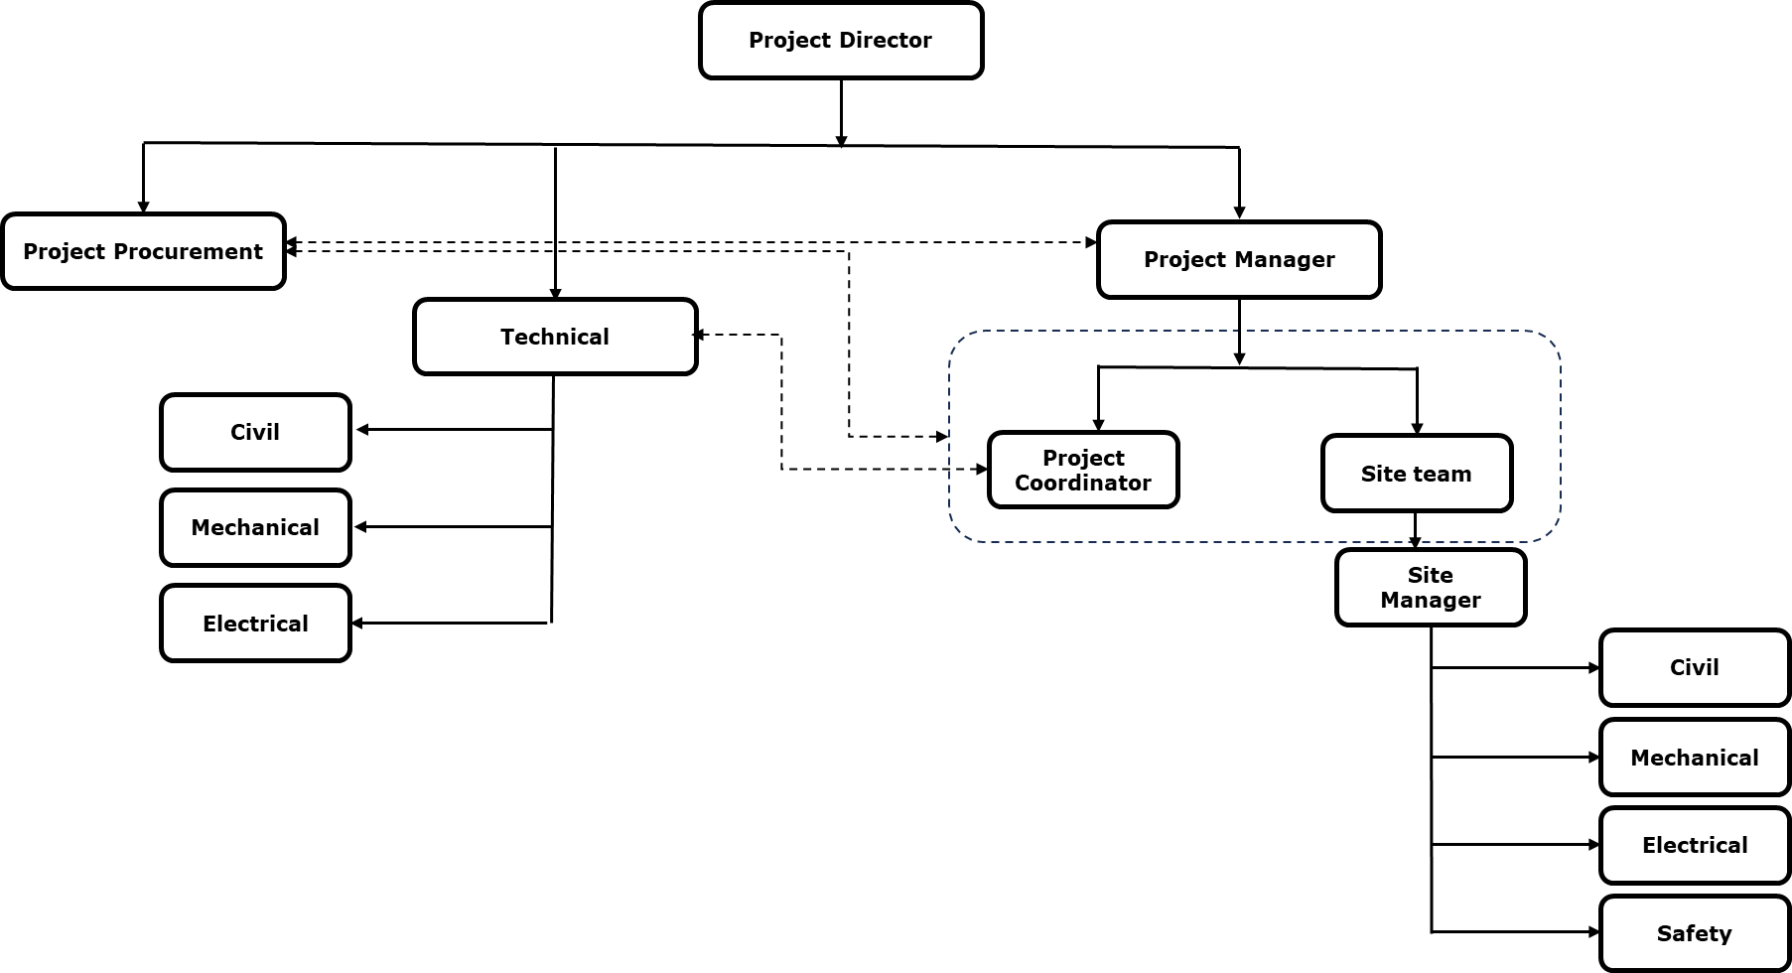

Direct reporting function

Cross functional communications

## PHASE – 1: Planning and Procurement

### Planning and Procurement

**Process Flow**



**Process Narrative**

|  |  |  |  |
| --- | --- | --- | --- |
| **Description** | **Performed By** | **Frequency** | **System / Manual** |
| **1.1 Review the Scope of Work**  Upon receiving the details of the Project, the project director will review the scope of work | **Project Director** | **Initial Stage of Project** | **Manual** |
| **1.2 Conduct Preliminary Investigation**  The Project team to conduct Preliminary investigation involving site surveys (ex - topography, geotechnical, hydrological, and marine, historical data analysis & other studies), environmental impact assessments, and regulatory compliance checks. | **Project Manager** | **Initial Stage of Project** | **Manual** |
| **1.3 Creating Layout and Tender drawing**  Concept engineering or tender level engineering shall be prepared either in assistance with Technical team or Technical consultant. | **Project Manager** | **Initial Stage of Project** | **Manual** |
| **1.4 Capex Budget estimation**  The Project is segmented into smaller packages. Based on historical project data and current market rates (budgetary quotes), the estimation for the project is made. | **Project Manager & Procurement Team** | **Initial Stage of Project** | **Manual** |
| **1.5 Review and Approval of Budget**  Comparative review of the capex budget with initial budget approved by management. In case of variance, the calculations are shared with BD team for reconciliation. The reconciled budget is then sent to Corporate finance for Financial closure. | **Project Director** | **As and when** | **Manual** |
| **1.6 Project Execution Plan – L1 Planning**  Planning team to identify all the specific task required to complete the project and represent a clear dependency between tasks along with the duration | **Project Manager + Project coordinator** | **Initial Stage of Project** | **Manual** |
| **1.6 Appointment of Technical Consultant**  Procurement team to finalize the consultant based on technical evaluation of the experience and bidding process. | **Procurement Team** | **Initial Stage of Project** | **Manual** |
| **1.7 Preparation of Detail Drawing & BOQ by consultant**  Based on the requirement of the Project and the Procurement strategy, the consultant shall prepare the drawings / BOQ / technical specs for the construction & procurement process. | **Consultant – External.** | **Initial Stage of Project** | **Manual** |
| **1.8 Review & approval of engineering documents**  The Project Co-Ordinator receives the drawings from the Technical consultant and with the assistance of the Project Manager & Technical team reviews the drawings / reports / specs. The comments/observations are discussed with the technical consultant and dwgs revised till the approval is provided. | **Project Manager & Project Team** | **Initial Stage of Project** | **Manual** |
| **1.9 Explore Market for Contractors & Vendors**  Procurement team explores the market to identify suitable suppliers / contractors for the respective work packages and float enquiries | **Procurement Team** | **As and when** | **Manual** |
| **1.11 Vendor Evaluation – Technical**  The Procurement team along with the technical team evaluate the technical capability of the suppliers / contractors and their proposed solutions. | **Procurement & Technical Team** | **As and when** | **Manual** |
| **1.12 Vendor Evaluation – Commercial**  The Procurement team does a comparative of all the quotations against the budgeted amount. | **Procurement Team** | **As and when** | **Manual** |
| **1.13 Negotiation**  If the vendor's quoted rate falls within the budget, the work order (WO) and onboarding process should proceed. However, if the quoted rate exceeds the budget, renegotiation with the vendor should be undertaken.  If, after multiple rounds of negotiation, the price still exceeds the budget, it will proceed through the approval process as per Construction Phase Clause 2: Budget Escalation. | **Procurement Team** | **As and when** | **Manual** |
| **1.14 Vendor Onboarding**  Collecting necessary information from suppliers  Orientation – Organization process & compliances. | **Procurement Team** | **As and when** | **Manual** |

### Coordination with Lender

**Process Flow**

  
**Process Narrative**

|  |  |  |  |
| --- | --- | --- | --- |
| **Description** | **Performed By** | **Frequency** | **System / Manual** |
| **2.1 Sharing the documents with Finance team for Lender Appointment**  Once all the documents (Budget, PEP, Schedule) are ready the Project Manager to compile all the documents and share it with the Finance team. | **Project Coordinator** | **As and when** | **Manual** |

## PHASE – 2: Construction Phase

### Construction Management

**Process Flow**



|  |  |  |  |
| --- | --- | --- | --- |
| **Description** | **Performed By** | **Frequency** | **System / Manual** |
| **1.1 GFC Drawings by Consultant**  The Project team to share the necessary project documents (specifications, scope of work) and get the drawings from consultant | **Project Coordinator** | **As and when** | **Manual** |
| **1.2 Drawings to be released on site**  The drawings provided by the Consultant must undergo a thorough review by the HO Technical team, the Site team, and the Independent Engineer. Any necessary revisions should be clearly communicated back to the Consultant, specifying the required changes. Only after receiving the approval from PM the finalized drawings be forwarded to the Site team for implementation. | **Project coordinator** | **As and when** | **Manual** |
| **1.3 Preparation of Work Method Statement (WMS) & QAP**  Upon receiving the drawings and understanding the scope of work, the contractor must develop the WMS (Work Method Statement) and submit it to the Project team for review and approval. | **Site manager** | **As and when** | **Manual** |
| **1.4 Review of Site work**  Site Engineer to review the work in accordance with the approved Good for Construction (GFC) drawing and ensure the work is done as per the constructor standards. | **Site Team** | **As and when** | **Manual** |
| **1.5 Coordination with Independent Engineer (IE) & Stakeholders**  Site team to coordinate with all the stakeholders & IE to ensure the smooth functioning of work by facilitating communication, aligning expectations, and addressing any concerns or requirements. | **Site Manager** | **As and when** | **Manual** |

**A: HSE and Quality Management**

The Contractor is required to strictly adhere to the HSE (Health, Safety, and Environment) and Quality Manual of J M Baxi Ports and Logistics Pvt Ltd during all phases of work execution. The site team must actively oversee operations to ensure compliance with the standards outlined in the HSE and Quality Manual. Any deviations must be promptly addressed to maintain safety, quality, and regulatory adherence at all times.

**Guiding Documents**

1. HSE Manual (JMBPL)
2. HSE Manual (Contractor)
3. Local Regulations
4. Statutory Permission

**B: Invoice Management**



**Process Narrative**

|  |  |  |  |
| --- | --- | --- | --- |
| **Description** | **Performed By** | **Frequency** | **System / Manual** |
| **B.1 Submission of Invoice by Contractor**  Site team to receive Bill from contractors for the work/supply. | **Site team** | **Monthly** | **Manual** |
| **B.2 Invoice Review and Validation**  Once the bills are received, site team to verify the RA bill against actual completion of work, review Joint Measurement Sheet along with all the invoice supporting documents.  After verification at site, the documents are sent to the Procurement team. The procurement team reviews the invoice for the correctness against the PO/WO and then makes the Certificate of Payment(COP).  After COP is prepared, it is to be approved by Project Manager and Project Director. | **Site team, Commercial team.** | **As and when** | **Manual** |
| **B.3 COP sent to Corporate Finance**  Once the Invoice is approved by Project Director the corporate finance team to initiate the payment to the contractor.  Corporate finance to coordinate with Accounts team or Lender for payment | **Corporate Finance** | **As and when** | **Manual** |

**C: Progress Monitoring**

The site team monitors the construction progress at the site along with the following works

1. Communication & managing the contractors at site
2. Communication & coordination with the authorities / client
3. Quality control of the work
4. Progress review against the Planning document.
5. Safety & risk management

The following documents are prepared by Site team in coordination with the Project coordinator to track the progress of the project.

1. Daily/ Weekly / Monthly Progress Report
2. Port/IE MPR, LI MPR

### Budget Escalation

**Process Flow**



**Process Narrative**

|  |  |  |  |
| --- | --- | --- | --- |
| **Description** | **Performed By** | **Frequency** | **System / Manual** |
| **2.1 Can be accommodated in contingency or other budget line item.**  If the budget is exceeding the initial approved budget, then check whether it can be accommodated in contingency or other budget line item.  If yes, then revise the PEP and budget. | **Procurement Team** | **As and when** | **Manual** |
| **2.2 Prepare an approval note with reason for Escalation.**  If the Budget can’t be accommodated in the Contingency, then prepare the approval note along with the reason for the Escalation and get the approval from PM & PD. | **Project Team** | **As and when** | **Manual** |
| * 1. **Present the Budget to Board**   Once approved by PD & PM then present the revised budget to board along with the reason and get the approval from them. | **Project Team** | **As and when** | **Manual** |
| * 1. **Corporate Finance Team to update Lender**   Once the Budget is approved by Board of Director, the Finance team to notify the lender about the revised budget. | **Corporate Finance Team** | **As and when** | **Manual** |
| * 1. **Incorporate the Revised Budget**   Once approved by Board of Directors, the planning team to update the Budget in PEP. | **Project Manager** | **As and when** | **Manual** |

### Project Closure and Handover

**Process Flow**



**Process Narrative**

|  |  |  |  |
| --- | --- | --- | --- |
| **Description** | **Performed By** | **Frequency** | **System / Manual** |
| **3.1 Pre Commissioning**  Site team to conduct a final inspection and pre commissioning of the completed work as per drawing with the contractor and compile a snag list, detailing any issues or defects that need to be addressed. Include specific rectifications required for each identified item. | **Site Team** | **As and when** | **Manual** |
| **3.2 Commissioning**  After the Site team completes the inspection, proceed with the commissioning. Identify any defects during this process and make the punch list of it. | **Site Team** | **As and when** | **Manual** |
| * 1. **Punch List**   Upon receiving the Punch list, promptly begin addressing and rectifying the identified issue. | **Site Team** | **As and when** | **Manual** |
| **3.4 Conducting Training and Handover to Operations Team**  Once the work is completed, site team shall arrange for the training and hand over the project to the Operations team, along with all the finalized as built drawing, operating manuals, warranty certificates, calibration certificate. | **Site Team** | **As and when** | **Manual** |
| **3.5 Final Invoice**  After completing the work and handing it over to operations team, the site team must initiate the final billing process for each contractor. the contractor to submit the final bill, accompanied by a reconciliation of materials. | **Commercial Team** | **As and when** | **Manual** |
| **3.6 Monitor/Assist Operation team in rectification during DLP**  If any defect arises during the defect liability period, the site team must coordinate with the contractor to ensure it is resolved promptly. | **Site Team** | **As and when** | **Manual** |
| **3.7 Request to release Bank Guarantee, Retention Money**  Once Defect Liability Period is over the contractor to email the commercial team regarding the release of BG & Retention money. | **Contractor** | **As and when** | **Manual** |
| **3.8 Release of Bank Guarantee, Retention Money**  Once the Defect Liability Period (DLP) concludes and all outstanding issues are resolved by the contractor, the Project Director (PD) to approve the release of the Bank Guarantee (BG) and Retention Money, ensuring that all contractual obligations have been fulfilled. | **Project Director** | **As and when** | **Manual** |

1. **Company/ Entity:** Any references/ mention of “entity” or “company” in the SOP refers to “J M Baxi Ports and Logistics Pvt Ltd”.